Univerzitet u Beogradu

Fakultet organizacionih nauka

Katedra za elektonsko poslovanje

REACT

Razvoj naprednih aplikacija elektronskog poslovanja

Mentor: Student:

Marko Bojanić 2023/3270

Beograd, 2023.

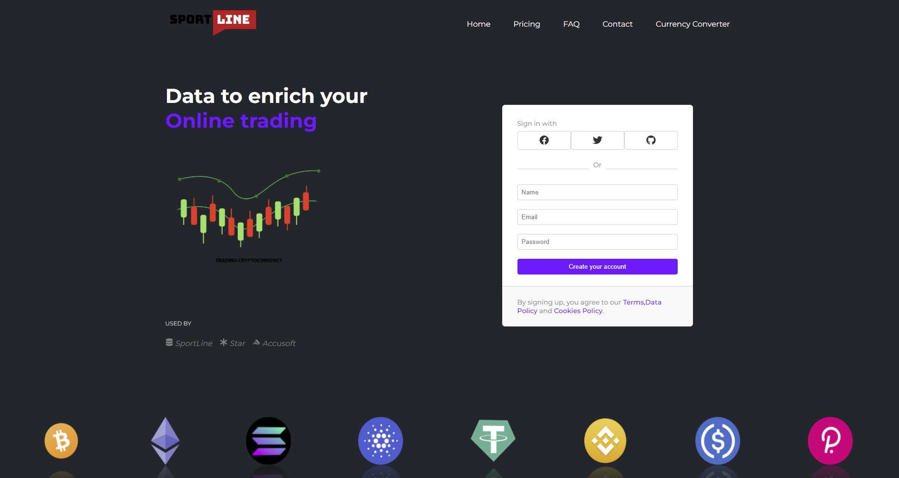

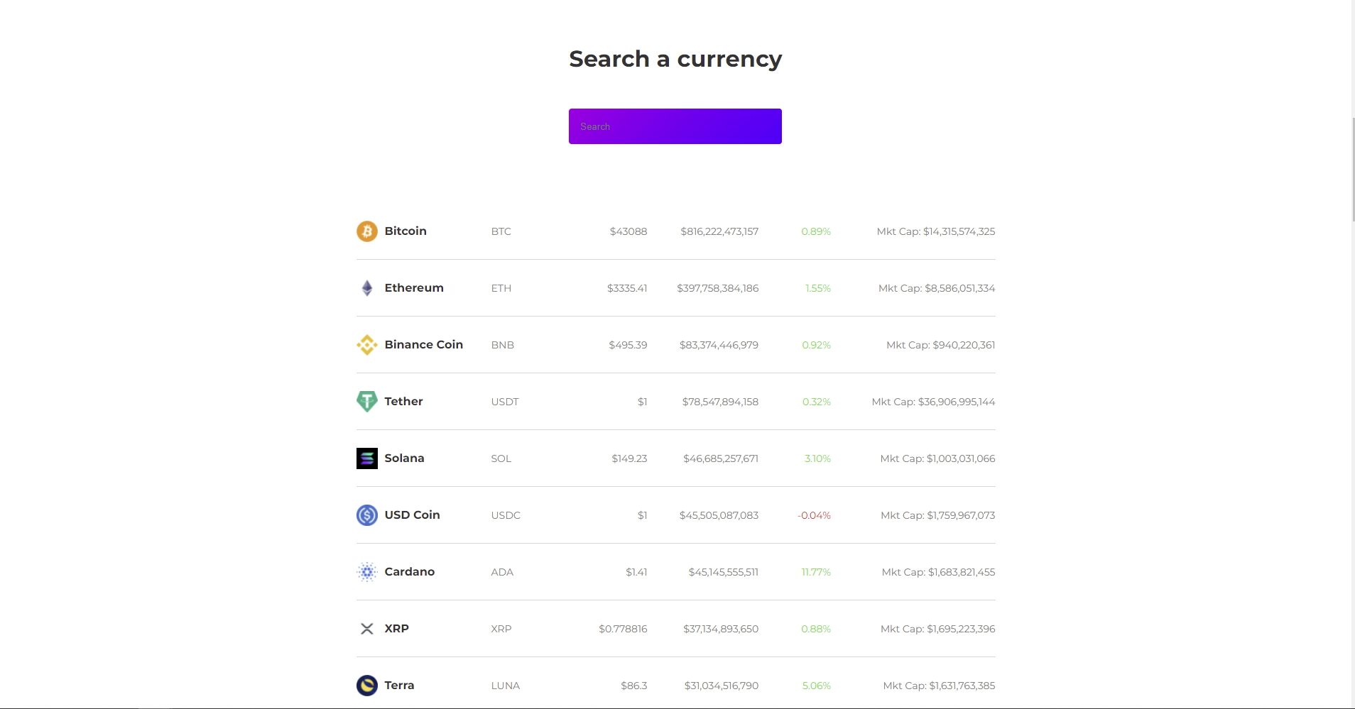



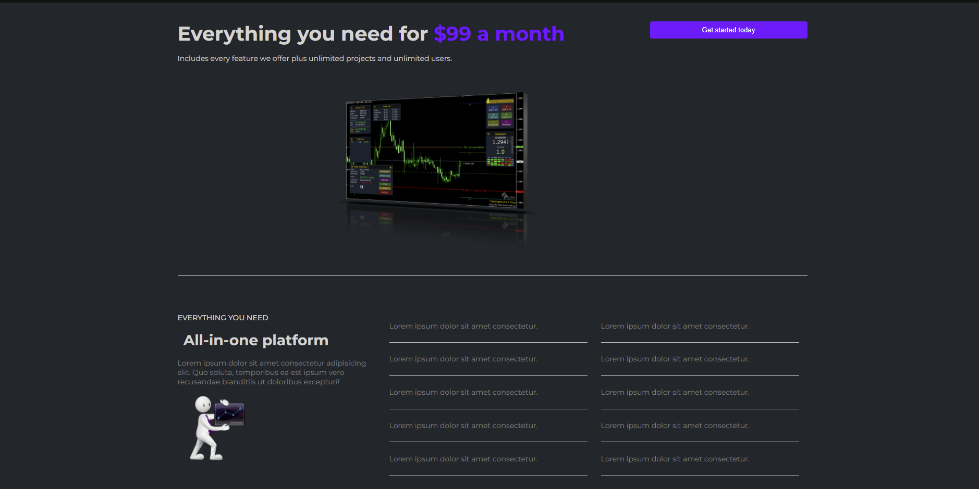



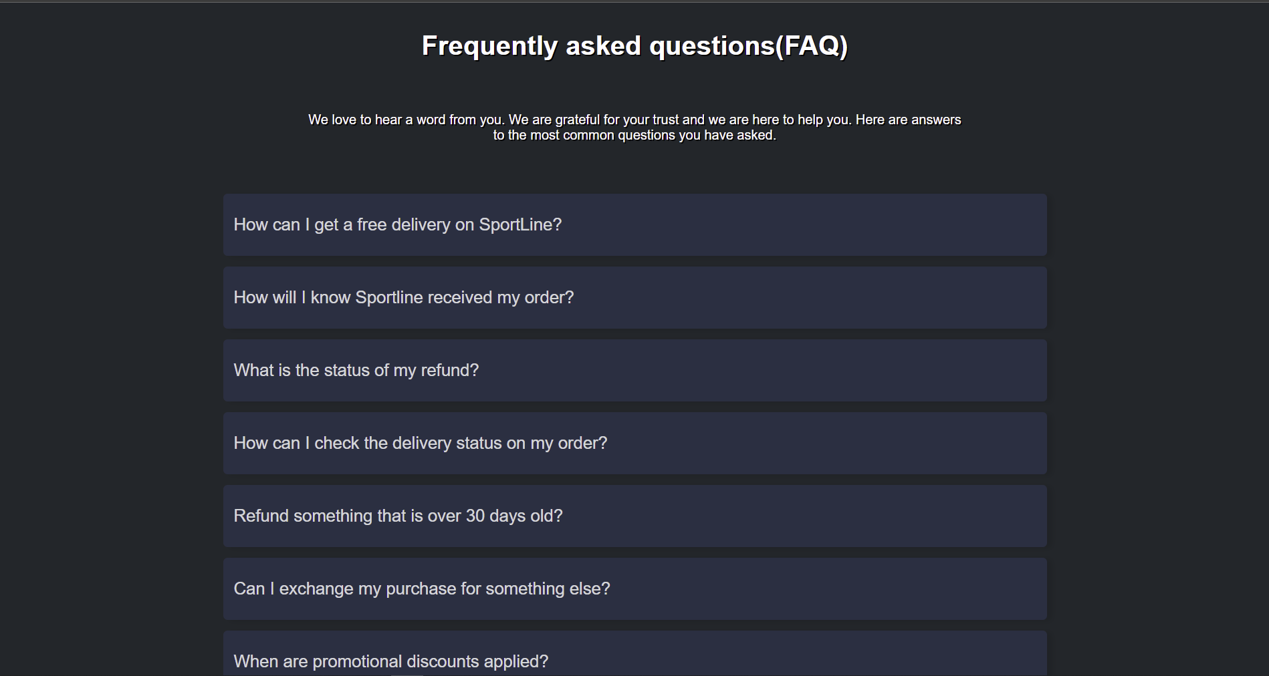

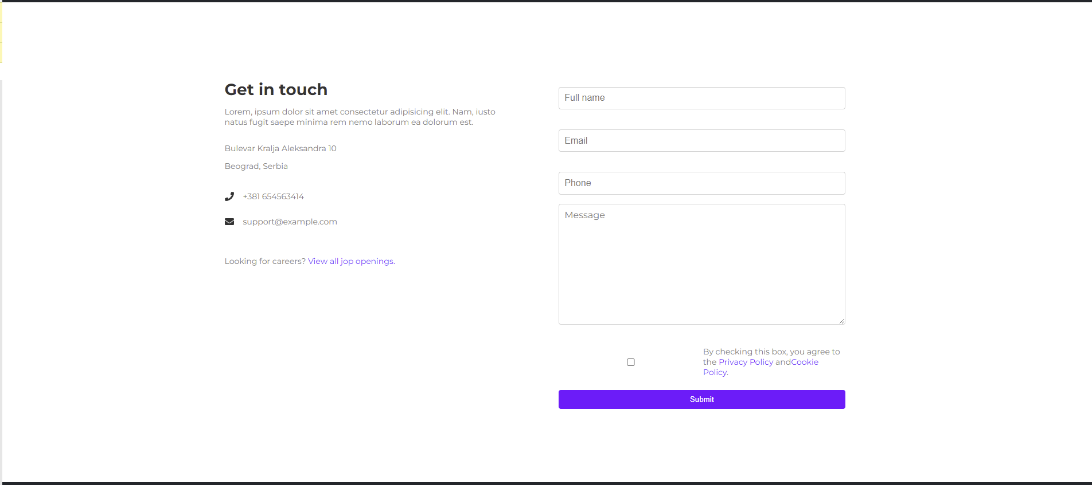

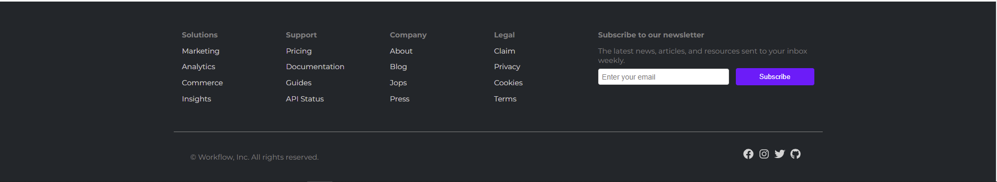

Prikaz github-a

[**https://github.com/MarkoBojanic18/react_project_master_studies.git**](https://github.com/MarkoBojanic18/react_project_master_studies.git)